**Assignment 17 June**

**Name – Atharva Jadhav Roll Number - DXC262AB12035**

**Batch – Dxc-262-Analytics-B12-Azure Company – DXC Technology**

**Employee Domain –Azure Analytics Training Under – Manipal Pro Learn**

1. Write a python program to predict car sales of a company by using the below data.

Year :2010 2011 2012 2013 2014 2015 2016 2017 2018 2019 2020

Sales in Millions :169 199 262 301 345 398 501 595 610 700 720

Display the outcome using linear regression method.

Code for deploying it:

import matplotlib.pyplot as plt

import numpy as np

from sklearn import linear_model

year = [2010,2011,2012,2013,2014,2015,2016,2017,2018,2019,2020]

sales = [169 , 199 , 262 , 301, 345 , 398 , 501, 595, 610 , 700 , 720]

print(sales)

new_sales = np.array(sales).reshape((-1,1))

print(new_sales)

reg_model=linear_model.LinearRegression()

reg_model.fit(new_sales,year)

print("Coefficient : ",reg_model.coef_)

print("Intercept : ", reg_model.intercept_)

def graph(formula,x_range):

x=np.array(x_range)

y=eval(formula)

plt.plot(x,y)

graph('reg_model.coef_*x+reg_model.intercept_',range(100,1000))

plt.scatter(new_sales,year,color='purple')

plt.ylabel("Year")

plt.xlabel("Sales in Million")

plt.show()

2. Write a python program to generate possible tuples from any two sample lists.

Code for deploying it:

test_tuple1 = (9,23)

test_tuple2 = (19,13)

print("The original Tuple 1 is : "+str(test_tuple1))

print("The original Tuple 2 is : "+str(test_tuple2))

res = [(a,b) for a in test_tuple1 for b in test_tuple2]

res = res + [[(a,b) for a in test_tuple2 for b in test_tuple1]]

print ("The Filtered Tuple is :" +str(res))

3. Create Azure Databricks and try to connect Databricks and power BI, explain the steps with screenshots.

**Step 1**: Create Azure Databricks by selecting the Databricks option by searching it.

Fill in all the necessary details and click on **Review + Create.**

When the validation completes, click on create and wait for the deployment process to finish.

**Step 2:** After the deployment is completed, click on **Go To Resource**.

**Step 3:** After launching the workspace, first create a cluster.

**Step 4:**  Then, create a notebook for computing any code that we need to perform and link it to the previous created cluster.

**Step 5:** Now, we need to create a table. While creating this table, we need to click on Partner Connect option to connect it with Power BI.

**Step 6:** Download the connection file and then use it. We need to generate and access token. For that, click on User settings and generate an access token.

Copy the token code and save it for future use.

**Step 7:** Open the connection file and login using the access token. Now, you can load the data and perform analytics on it. We can plot and verify the data and present it in different formats.

**4.Create Azure Synapse & connect with Azure Blob, explain the steps with screenshots**

Go to azure portal, search for Azure Synapse, click on it.

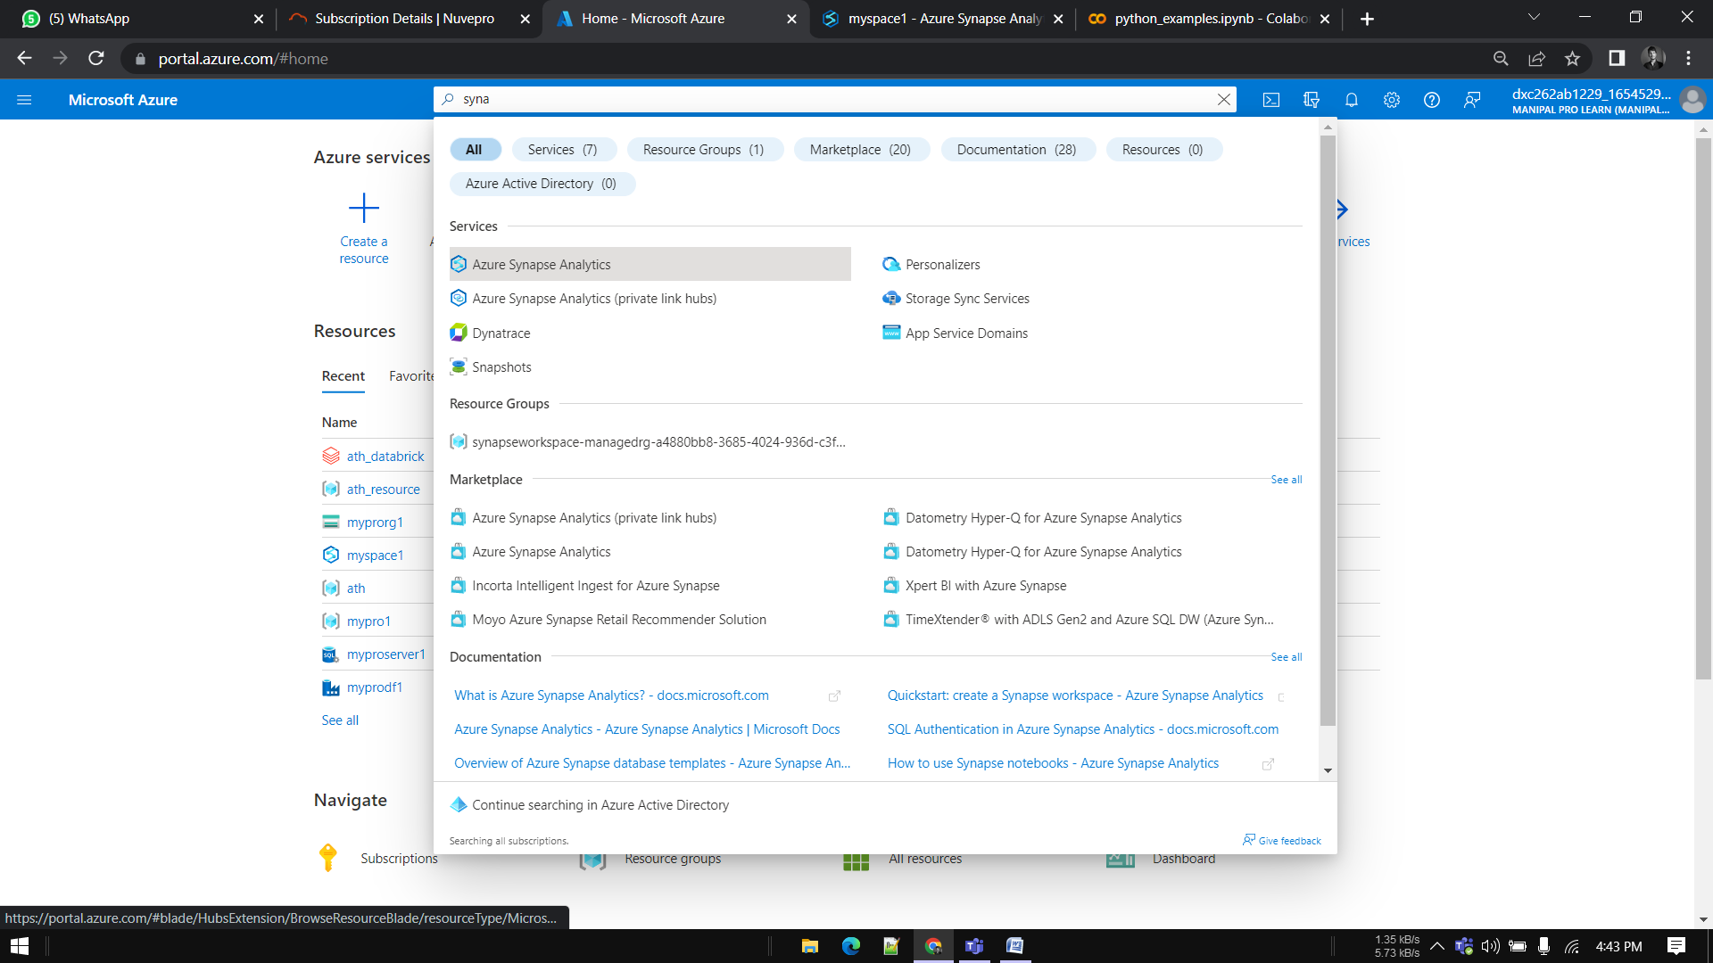

Enter required Information and click on review and create

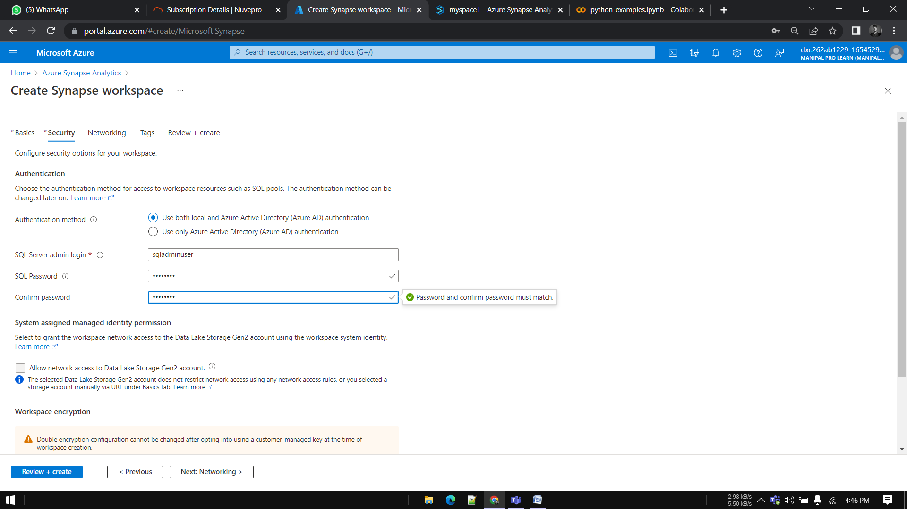

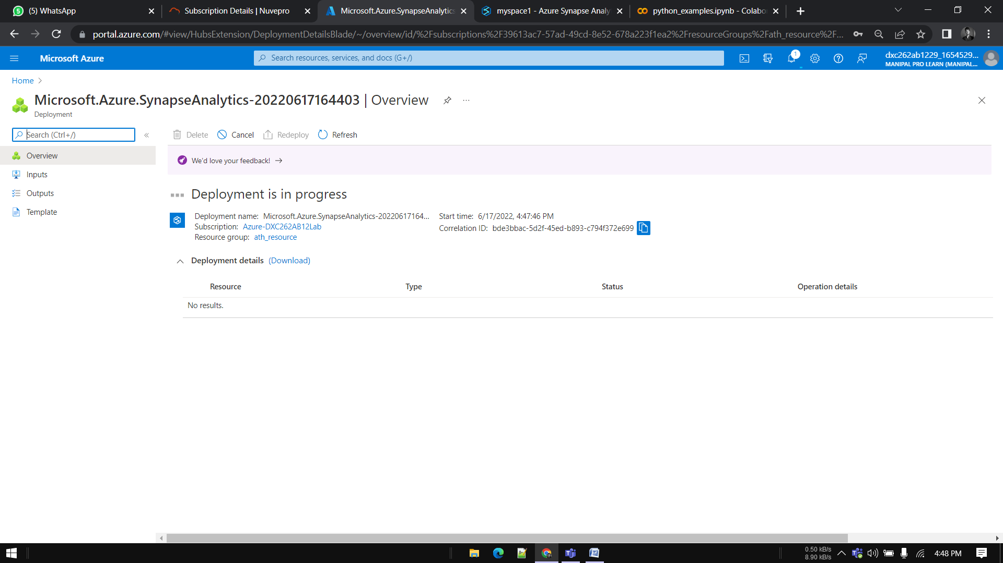

Click on open synapse studio

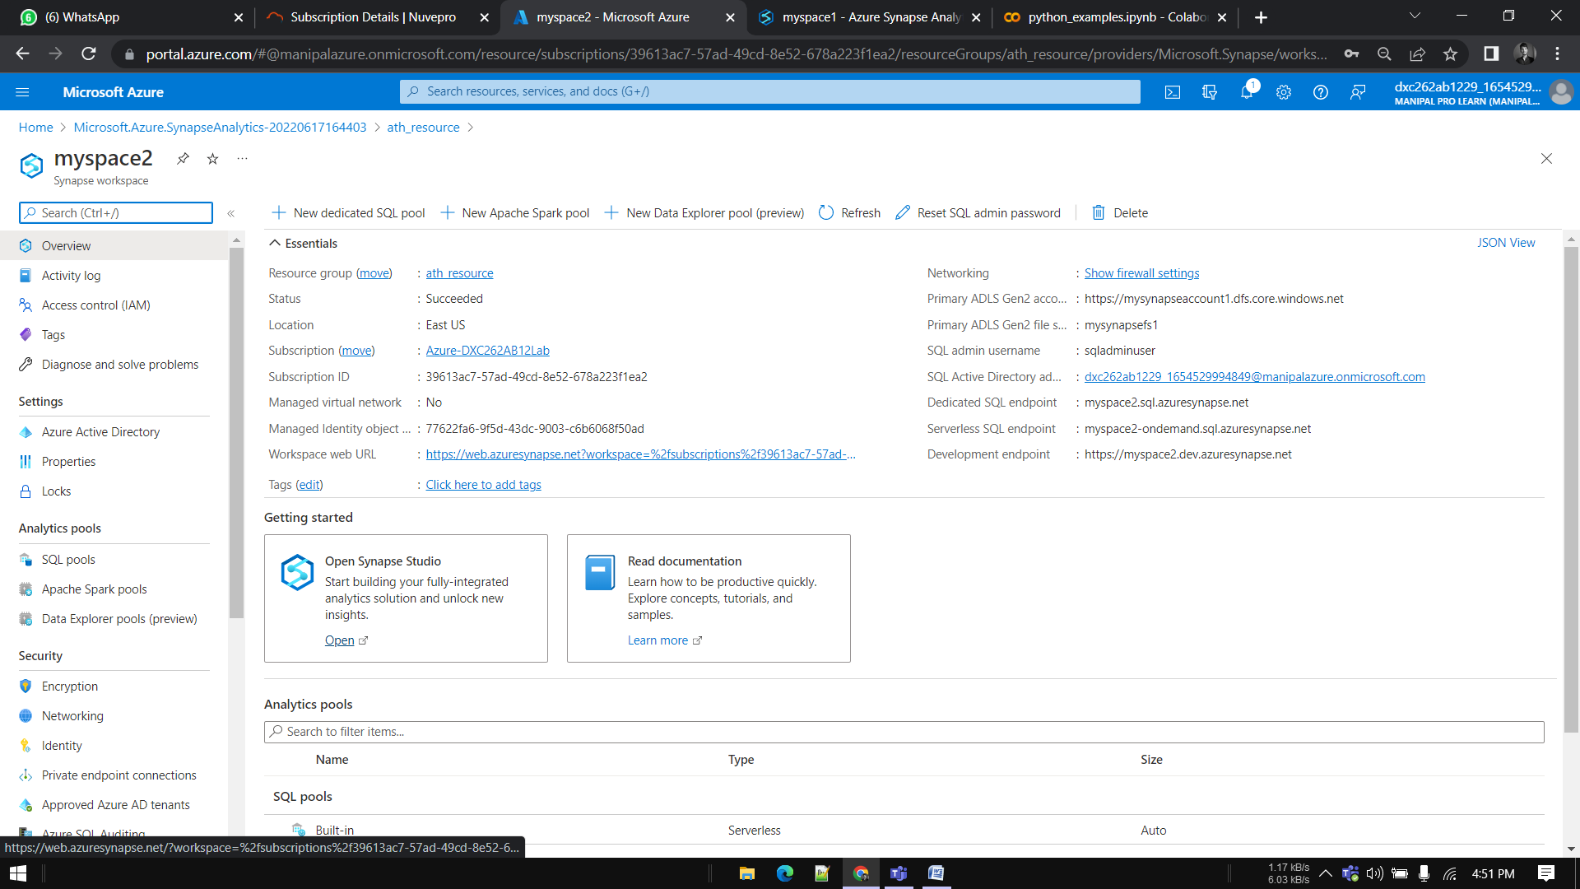

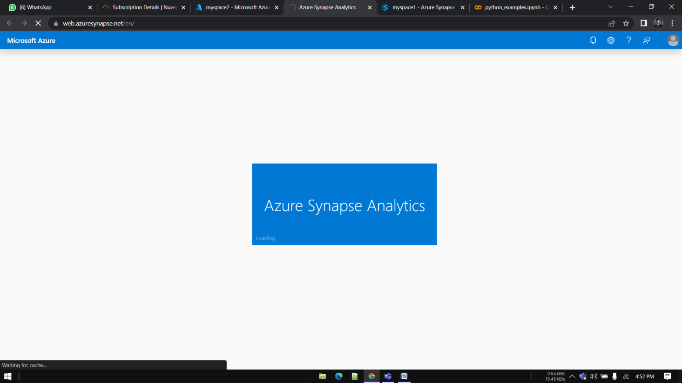

Till then create a storage account and add a container in it

Select public access level as blob

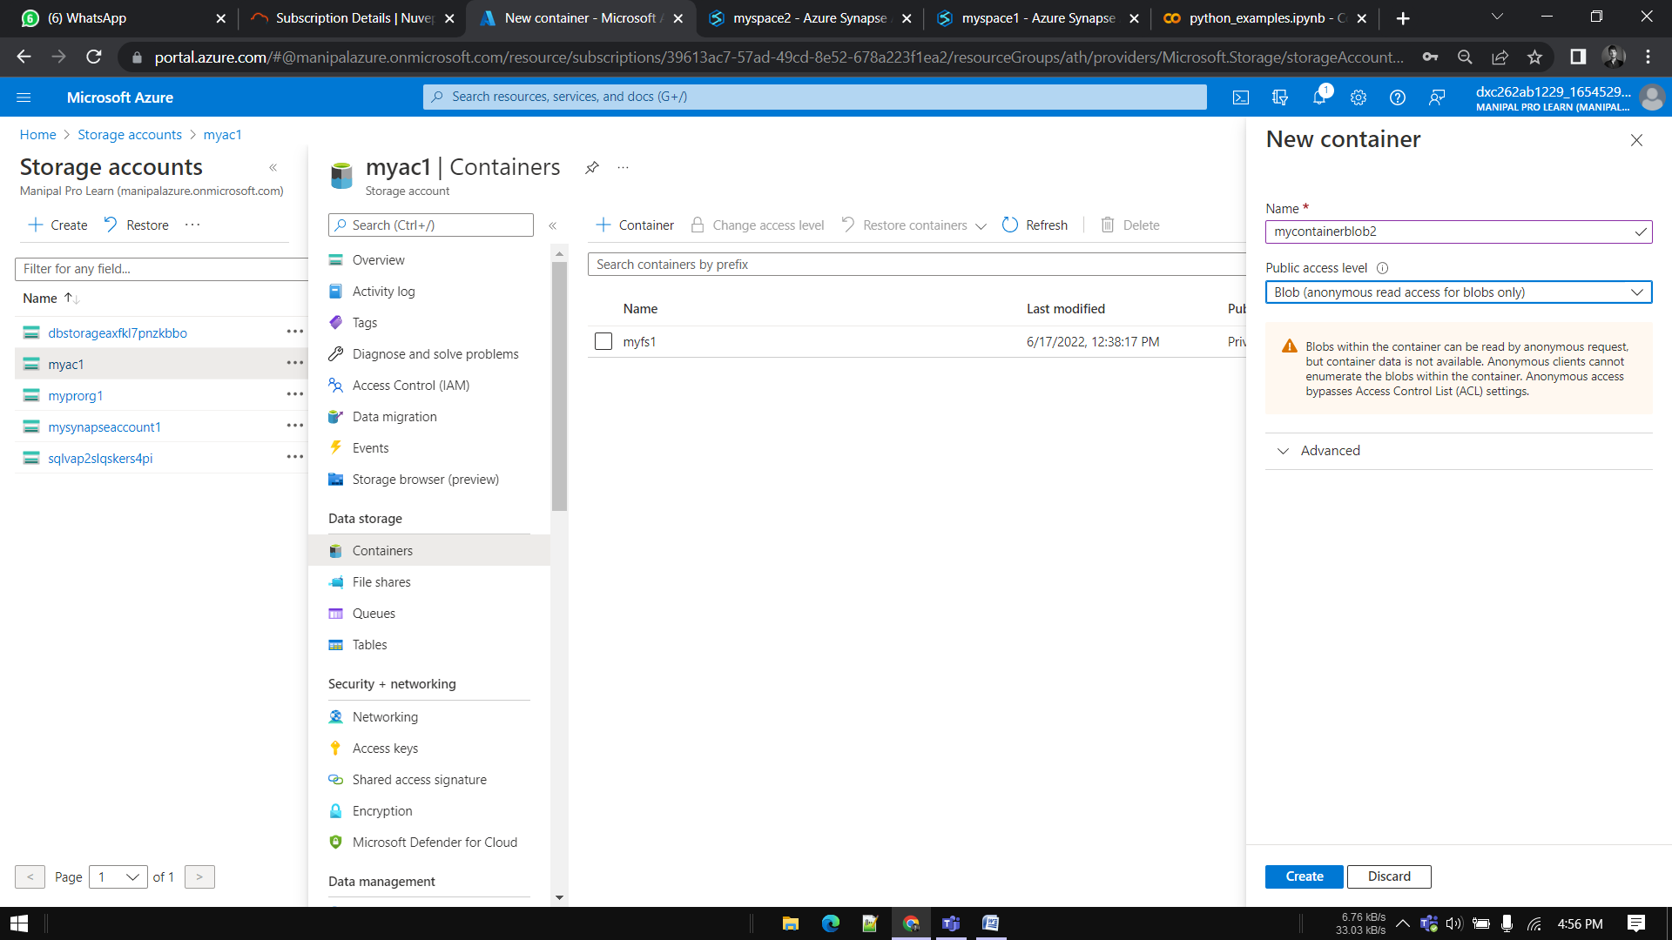

Go to blob and upload a file



Now go to synapse and navigate to data and click on + icon, connect to external data

To create a new linked service

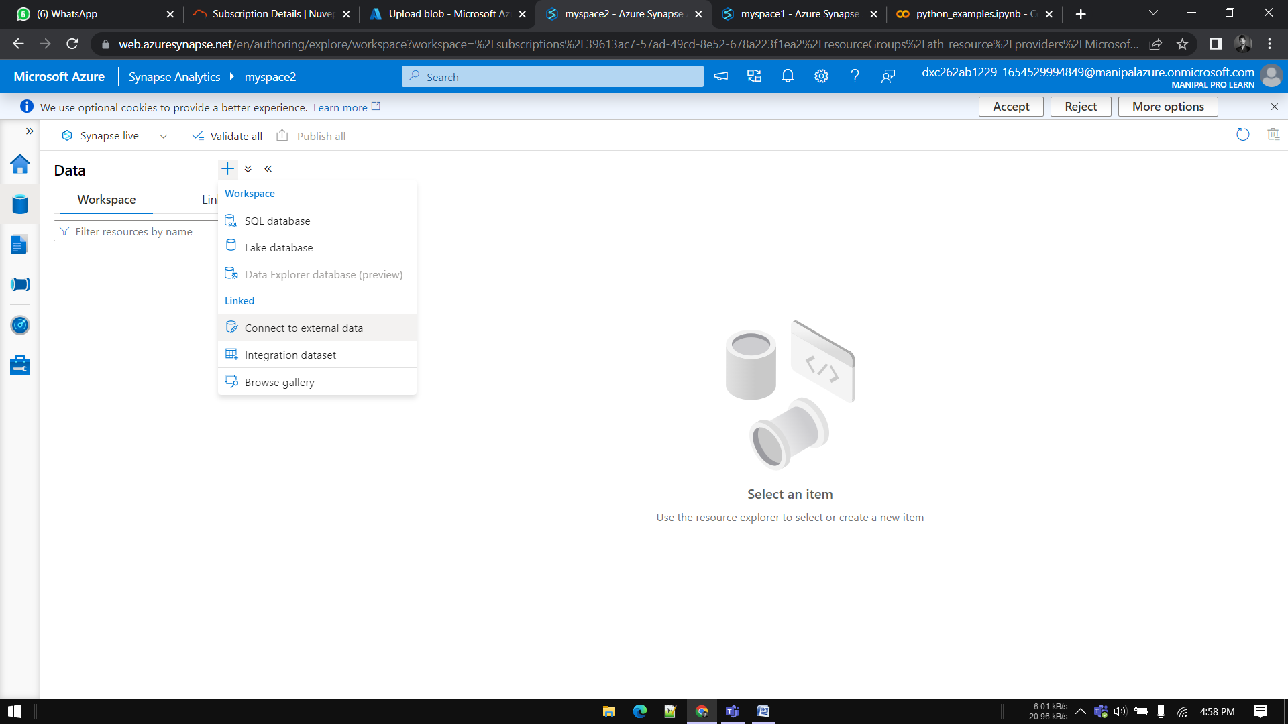

Select azure blob storage

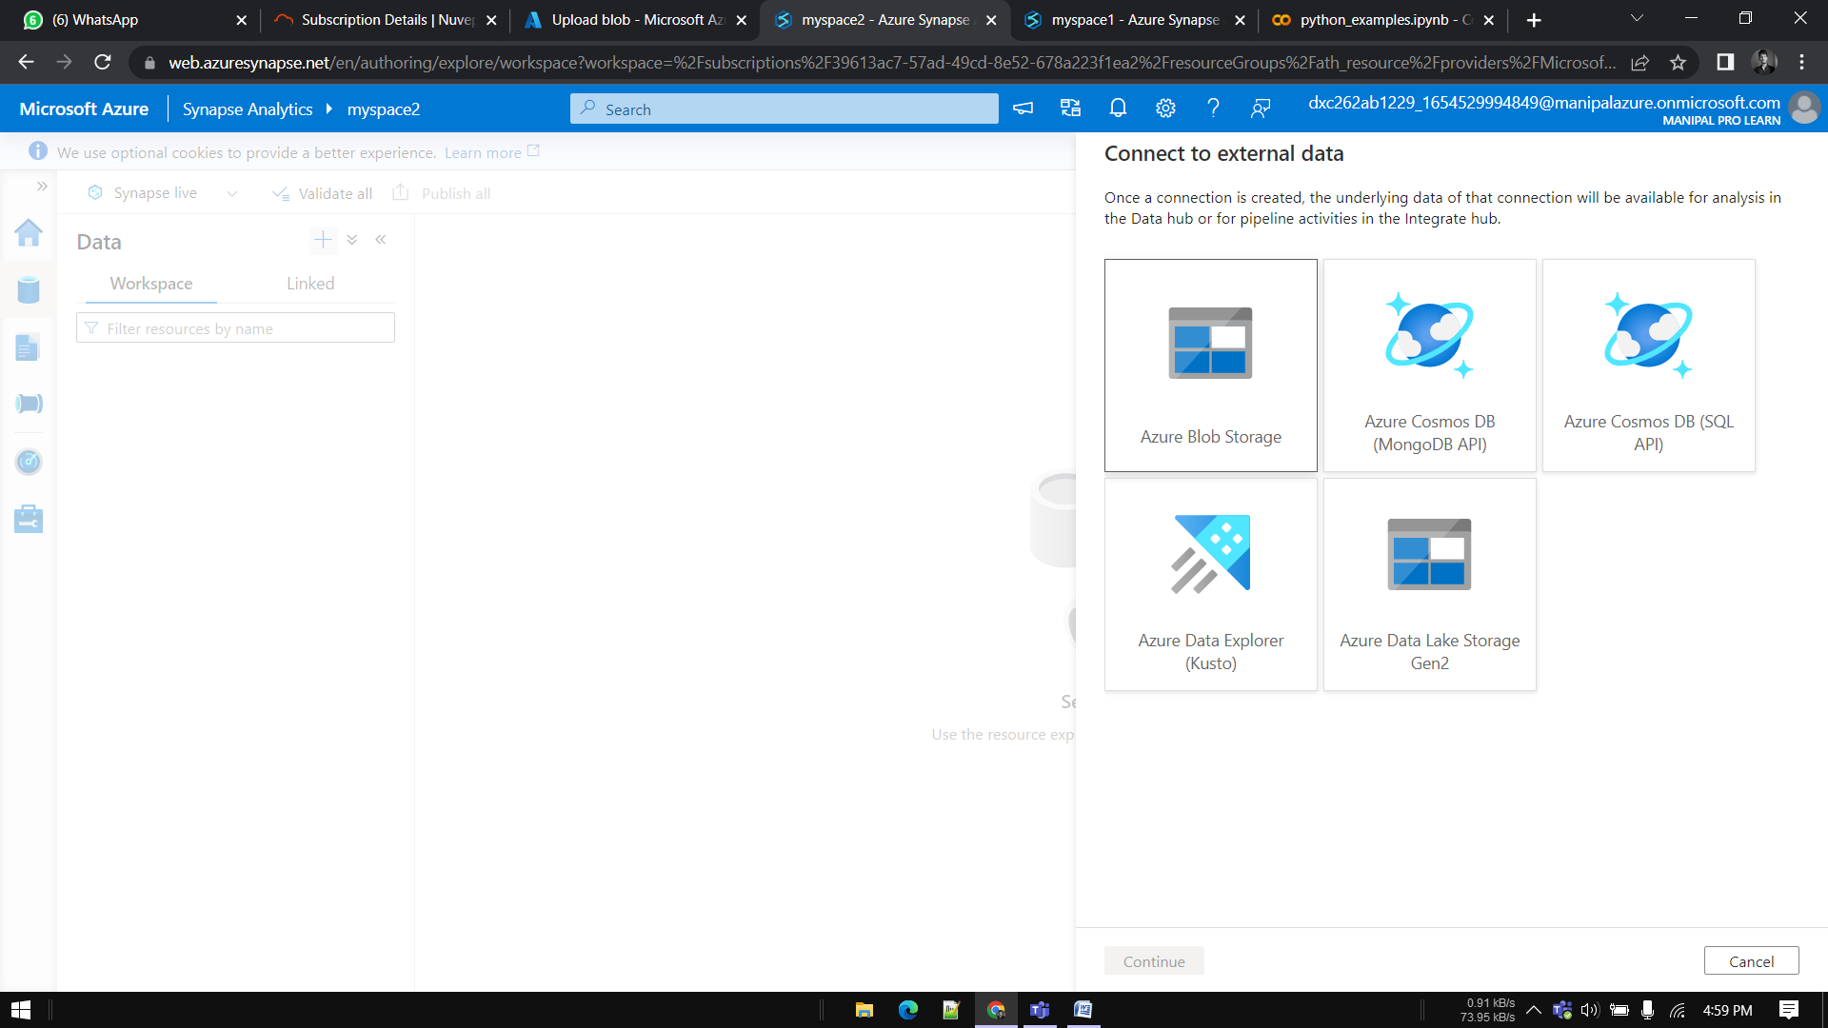

Enter details, select storage account name that we created earlier, click on test connection then click on create

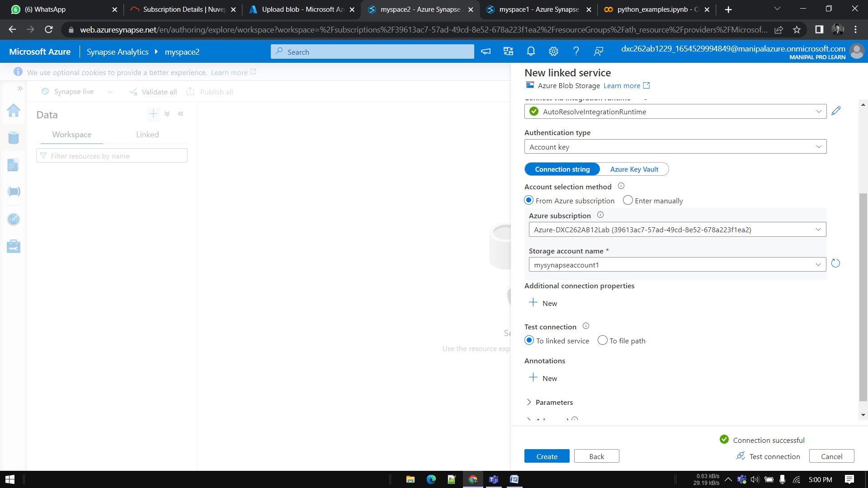

Now you will be able to see the file that we have uploaded to blob

That means We **Created Azure Synapse & connected it with with Azure Blob successfully**

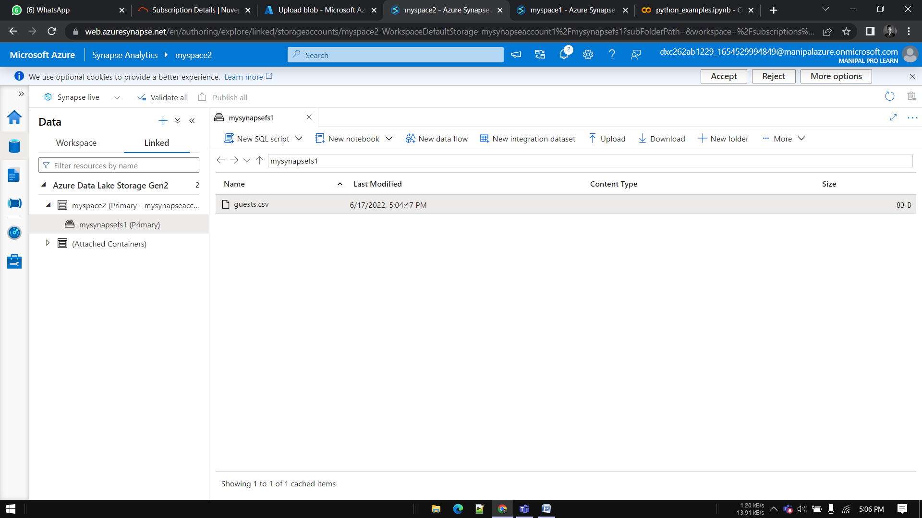

**5.Create Azure Synapse spark pool & query sample JSON file,  
explain the steps with screenshots**

Go to Synapse analytics and click on **manage pools**

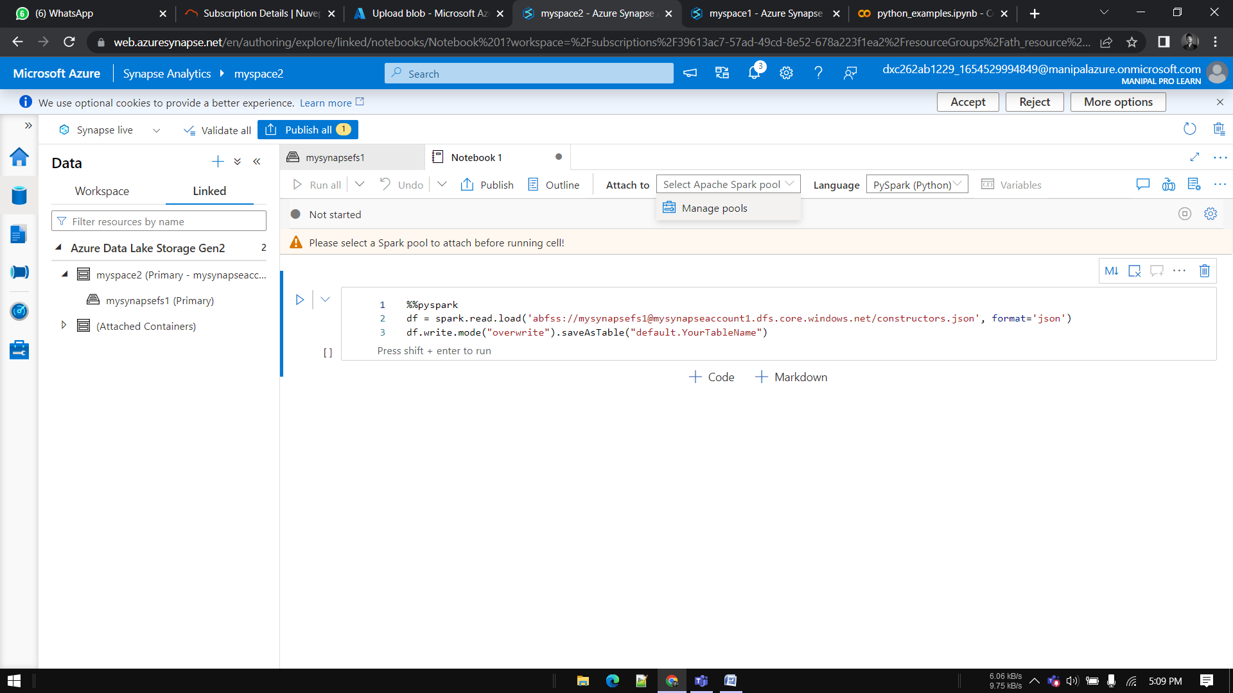

Click on create

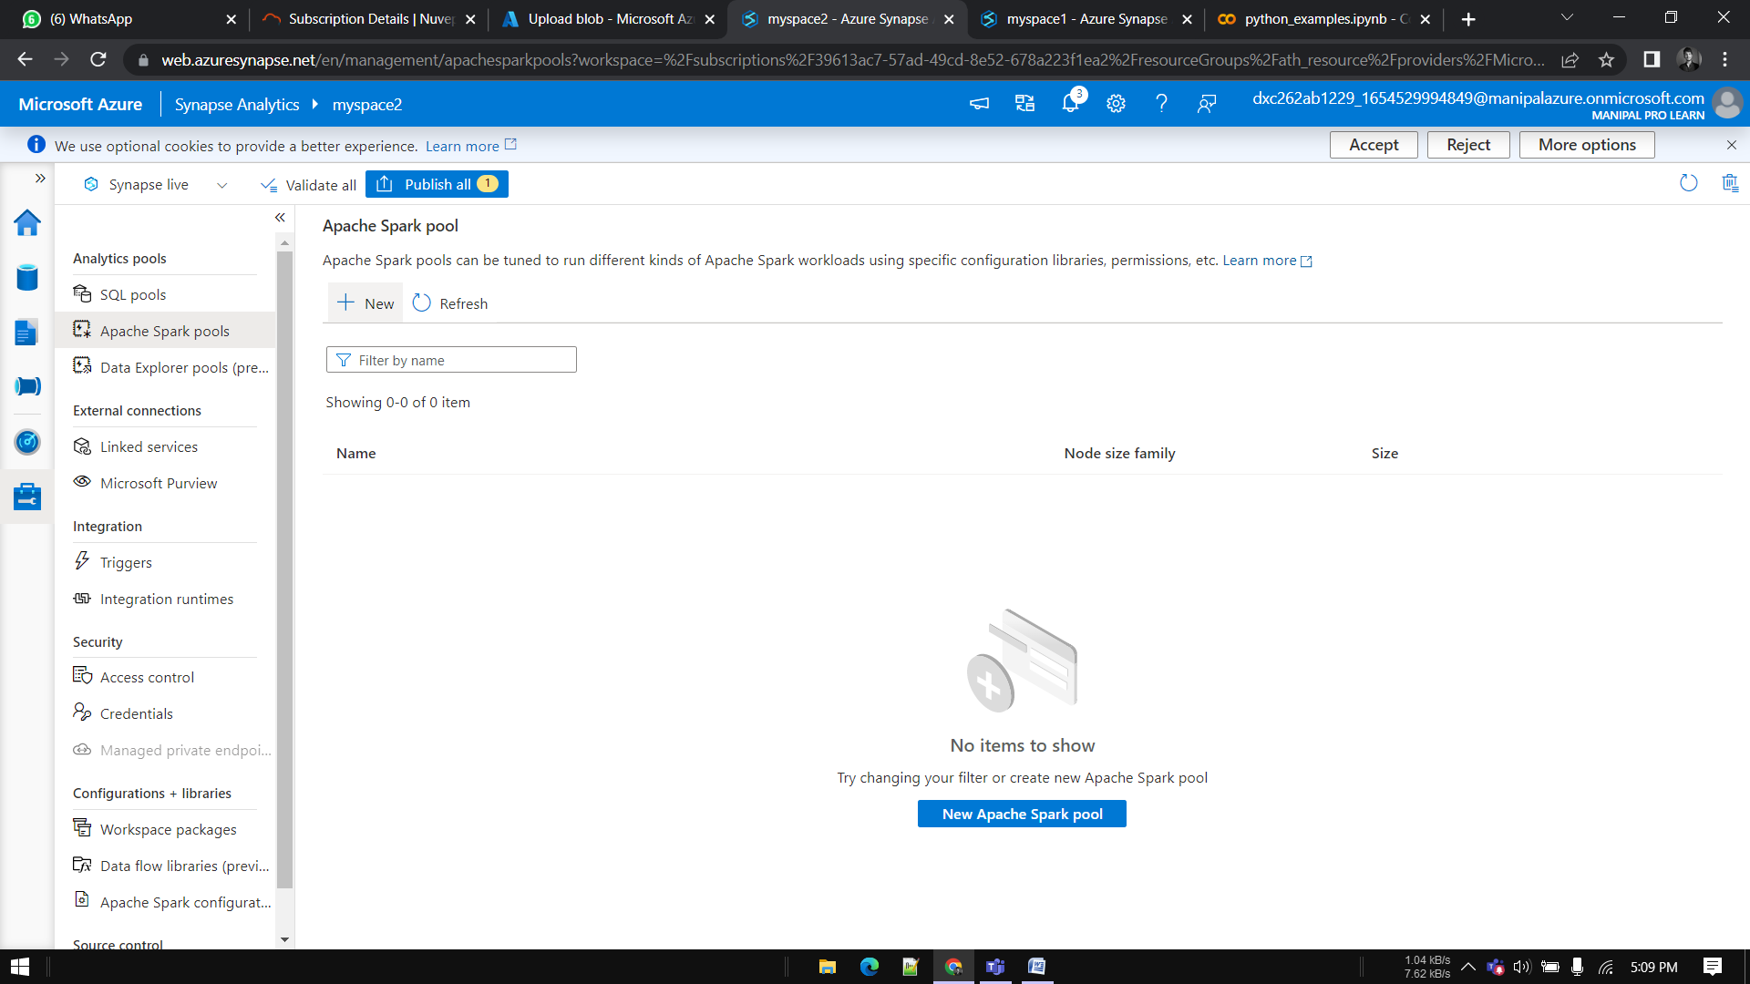

Enter details and click on create

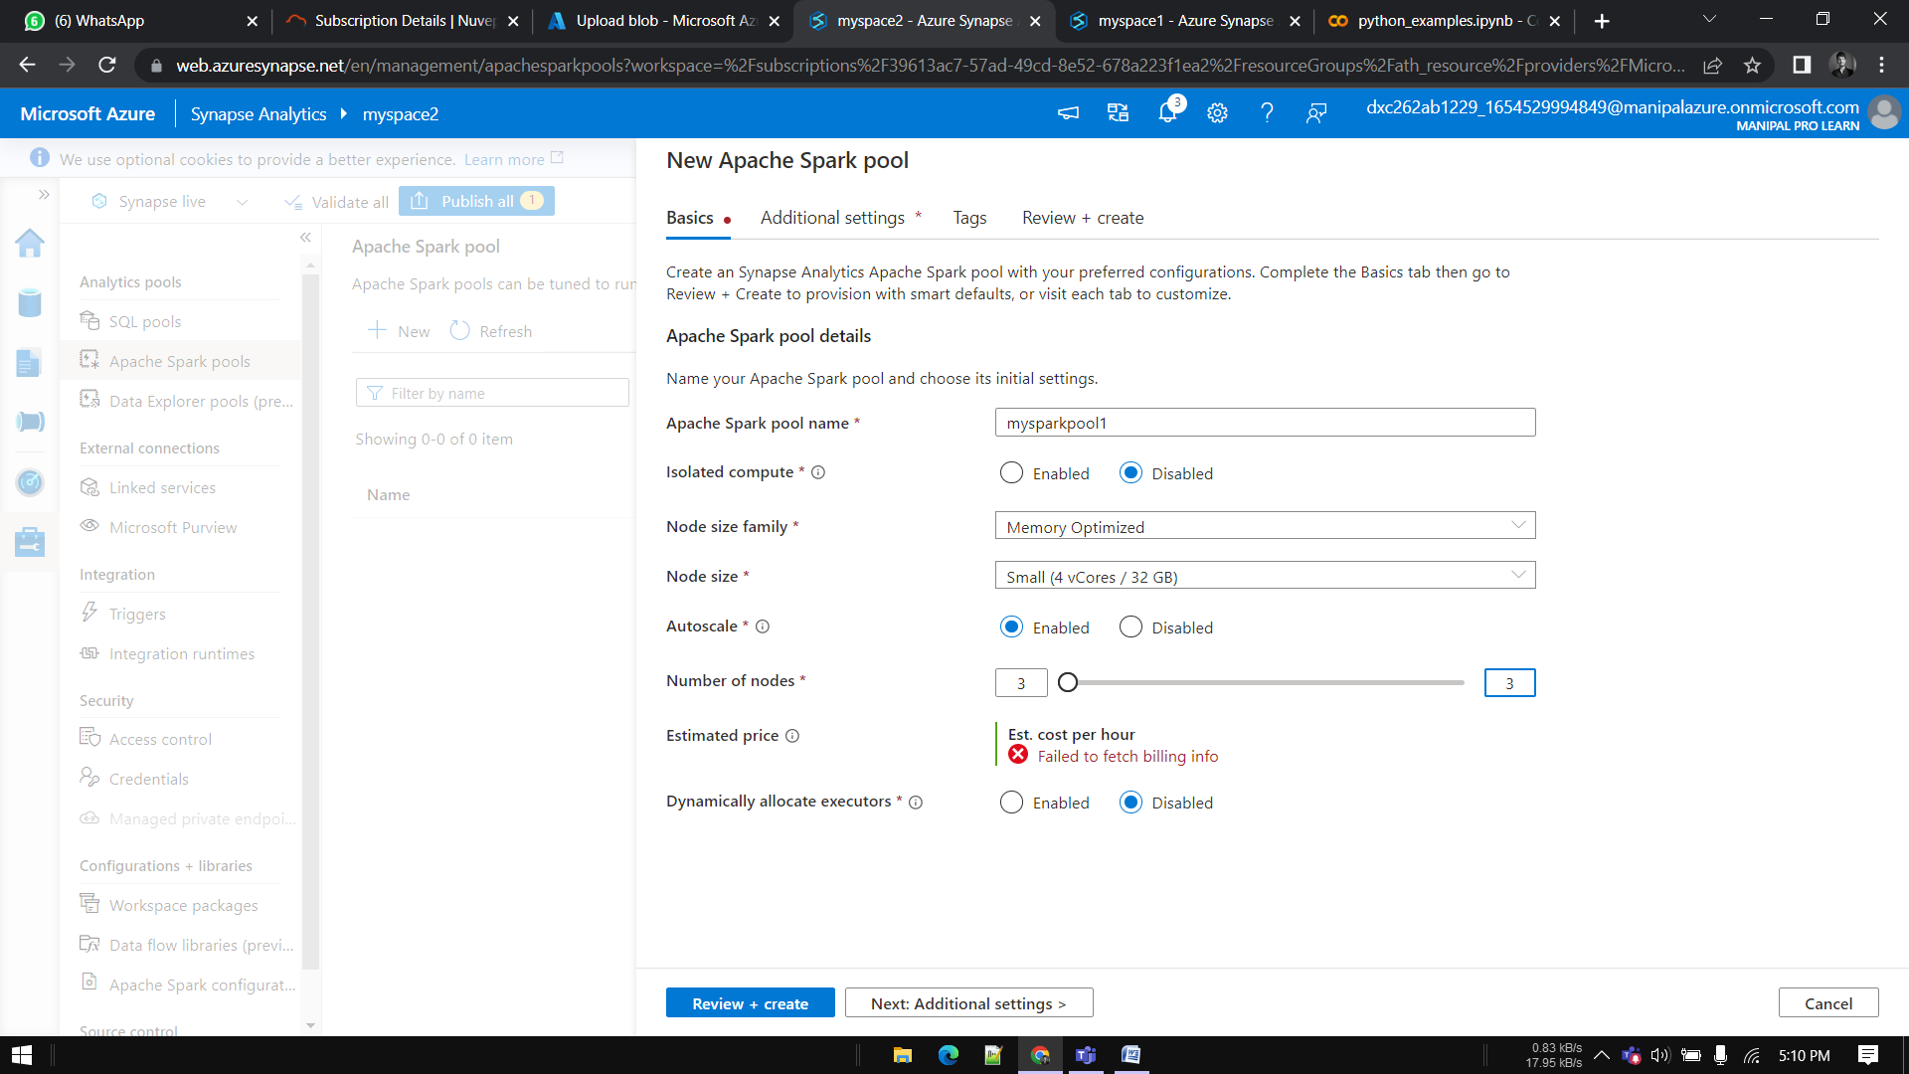

After deploying click on attach to and select your sparkpool

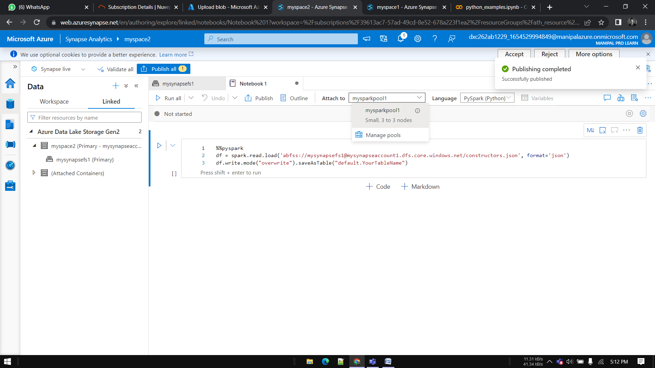

Click on publish and run

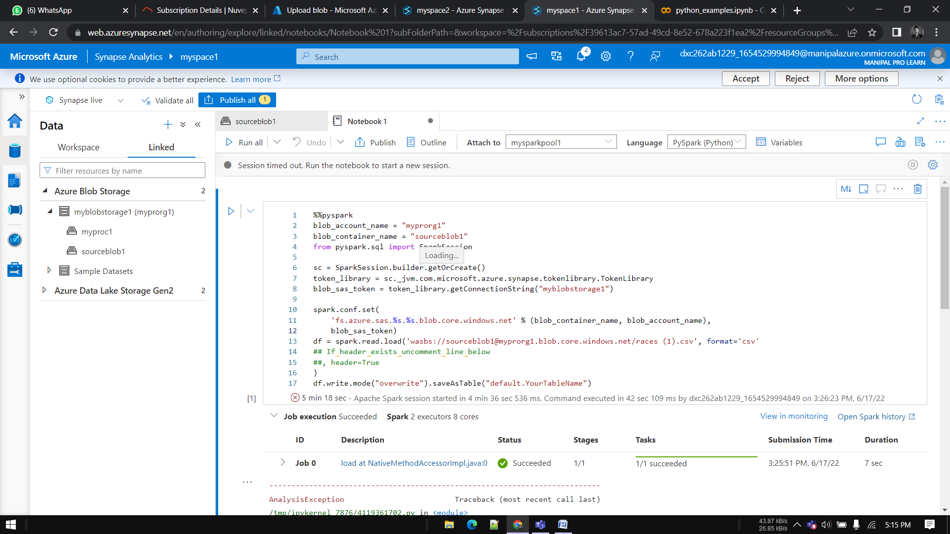

**6.Create Azure Cosmos DB & import sample JSON file, explain the steps with screenshots**

 Sample JSON file to upload

Now here we have successfully uploaded data into the Cosmos DB sql container.

**7.Connect COSMOS DB & Azure Synapse analytics & explain the steps with screenshots.**

Here we have successfully loaded Cosmos DB sample json data into the Azure synapse lab.